RECYCLING TIPS FROM…
THE GOOD EGG

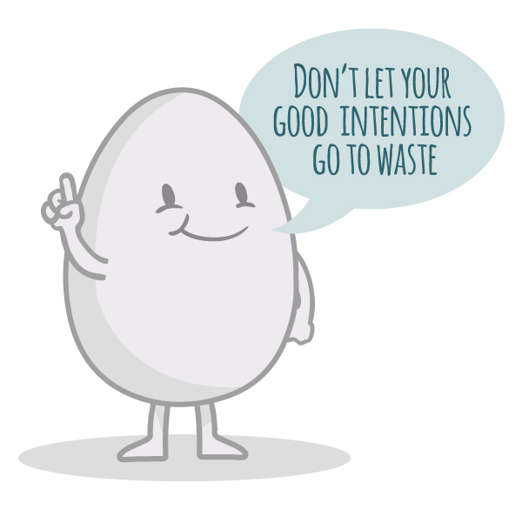

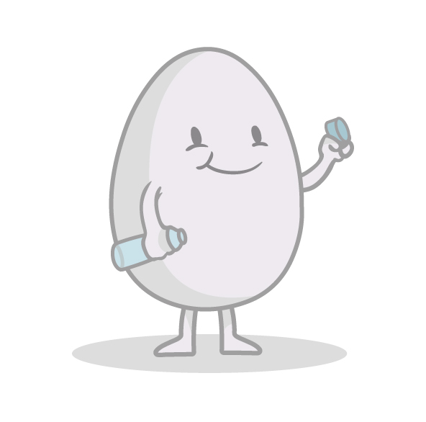

Always remove lids from bottles before placing in the recycling bin.
This helps the recycling facility sort the containers and ensures containers are empty.
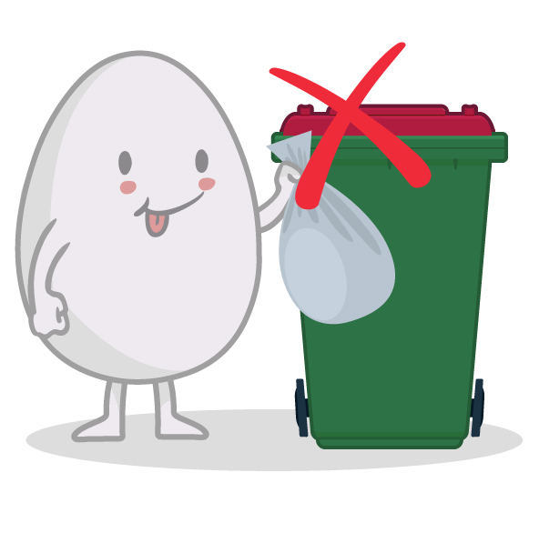

Remove recycling from plastic bags- items in plastic bags will not be recycled
For safety reasons, staff at the recycling facility will not open plastic bags to reveal the contents. Please place all recyclable items loose in your bin.

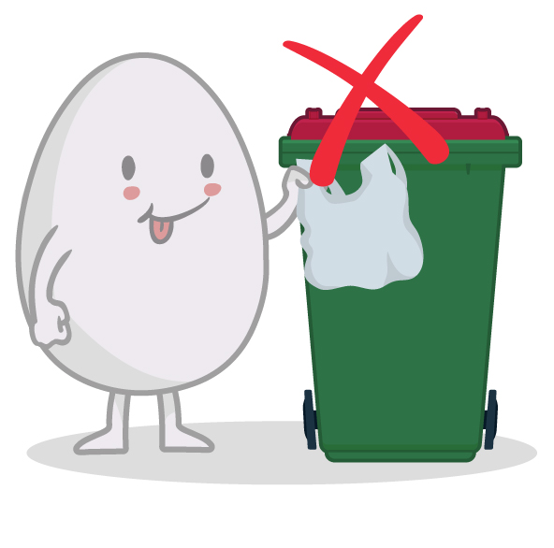

Soft plastics and plastic bags cannot be recycled by placing them into your red top recycling bin
Soft plastics cannot be isolated from other waste at the Material Recovery Facility and often become contaminants in the paper streams. Soft plastic can be recycled through the Redcycle program. Collection points are located at all Coles and Woolworths supermarkets.

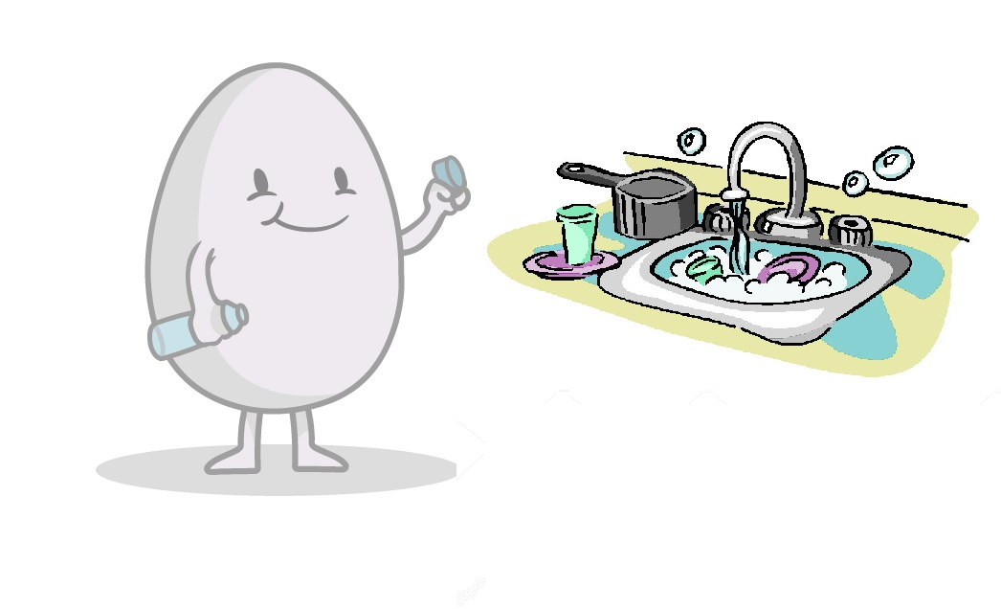

Always make sure containers have been cleaned before placing in your red top recycling bin
With the new stricter acceptance guidelines for recycling it is essential that all containers are washed before placing into the recycling bin. This can easily be achieved by washing these items after the dishes.

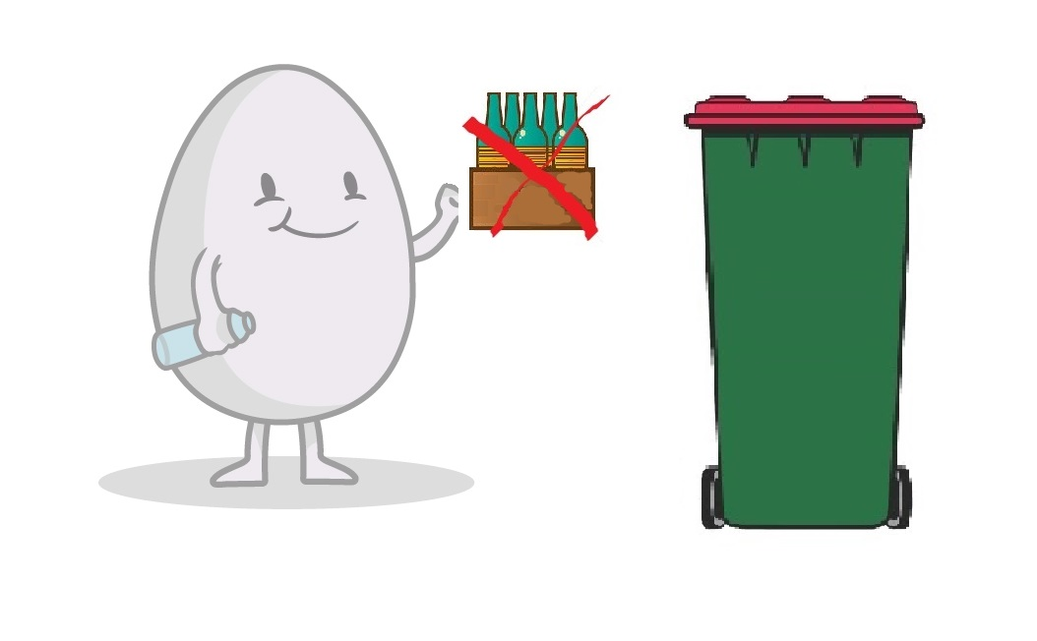

Always remove recyclables from cardboard boxes before placing into your red top recycling bin
Items in boxes may not be able to be separated at the Materials Recovery Facility and for safety reasons staff will not open boxes to reveal contents. Please place all recyclable items loose in your bin.

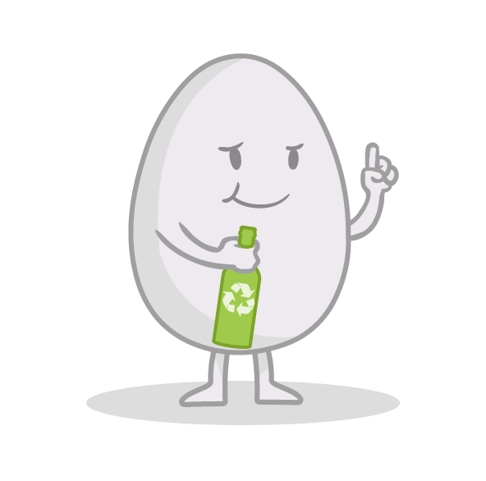

A recycling symbol on a product or packaging does not necessarily indicate it can recycled by placing into your red top recycling bin
Many products and packaging can contain a recycling symbol however this does not mean that they can be placed into your recycling bin. For a clear explanation of exactly what can go into the recycling bin please refer to the Cleanaway recycling flyer below which is also available on the Shire website: https://www.denmark.wa.gov.au/residents/waste-services/waste-news.aspx
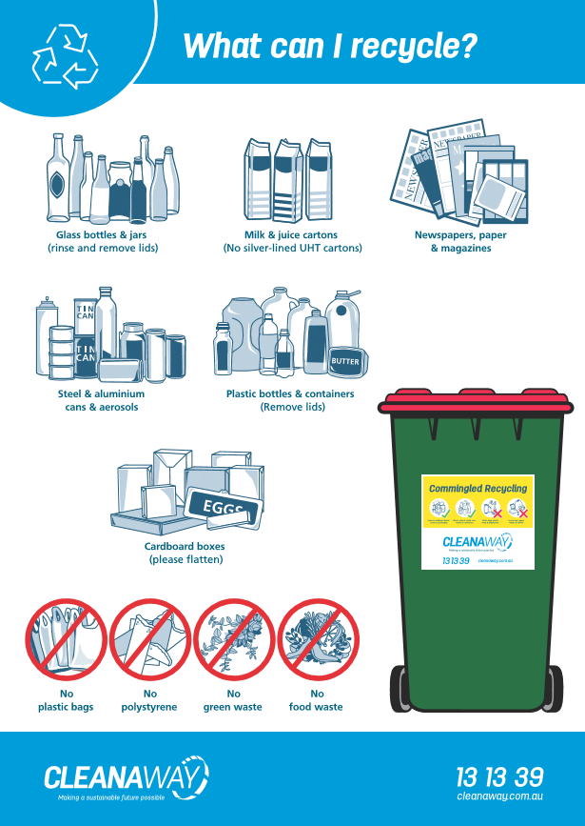

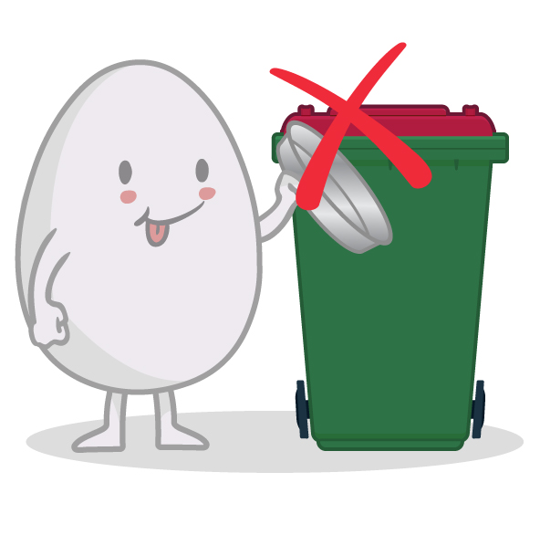

Aluminium foil and disposable baking trays cannot be recycled in your red top recycling bin
Aluminium foil and trays are not heavy enough to be picked up and separated from other items which means they do not get recycled at the Material Recovery Facility. Please place aluminium foil and trays into the general waste bin.

Recycling Tip
Watch Cleanaway’s video of operations at the Albany Material Recovery Facility to see where your recycling goes after the truck collects your bin.
https://youtu.be/-YOvskrsKnw

Recycling Tip
What is the best way to determine what should go into the recycling bin? Referring to Cleanaway’s recycling flyer will ensure that you always put the correct things into the recycling bin.

https://www.denmark.wa.gov.au/residents/waste-services/waste-news.aspx

