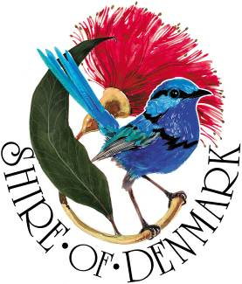
Shire of Denmark
Discover Denmark

Event Providers
Expression of Interest
Australia Day Event
_________________________________________________________________________________________________

The Shire of Denmark is inviting Expressions of Interest (EOI) for its Australia Day event from suitably qualified and experienced:

- Food & beverage vendors (ice-cream, non-alcoholic drinks, coffee, various food)
- Children entertainment providers (eg – Face-painters, arts & crafts etc)
- Musicians /Bands (3)

Event Information
Event: Australia Day Twilight Music Festival
Location: Berridge Park, Hollings Road, Denmark
Date: 26 January 2022
Event Time: From 4 – 7pm

Criteria
- Preference will be given to local Denmark providers.
- Previous experience performing/trading at community events are desirable
- Providers must follow the Shire of Denmark Strategic Community Plan and Sustainability Practice.
- Shire of Denmark supports inclusivity and encourages applications from people of diverse background, culture and abilities.

For the full criteria visit www.denmark.wa.gov.au/Aus-Day-EOI

How to apply
Complete the application online at www.denmark.wa.gov.au/Aus-Day-EOI or email your completed form to enquiries@denmark.wa.gov.au

Expressions of Interest must be submitted by 4pm, Friday 3 January, 2022

Further Information
For further information please contact the Shire’s Community Development Officer Rosie Arnephie.

08 9848 0333
Rosemarie.Arnephie@denmark.wa.gov.au
www.denmark.wa.gov.au/Aus-Day-EOI

