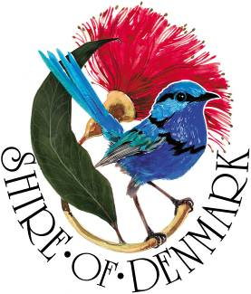
Shire of Denmark
Discover Denmark

Children’s Entertainment Providers
Expression of Interest Criteria
Australia Day Event
_________________________________________________________________________________________________

The Shire of Denmark is seeking expressions of interest from entertainment providers for our Australia Day community event on Wednesday 26 January 2022.

The Shire of Denmark supports inclusivity and encourages applications from people of diverse backgrounds, cultures and abilities.

Event Information
Event Location: Berridge Park, Hollings Road Denmark
Event Date and Time: 4 - 7 pm, Wednesday 26 January 2022

Requirements
We are seeking the following but not limited to:
- Face-painters
- Arts and crafts activities
- Story-tellers
- Successful applicants will be required to follow any legislative requirements in accordance with Department of Health legislations and OHS guidelines

Selections
Entertainment providers will be selected based on the above criteria, cost and on best fit for the event.

How to apply
Submit your interest online at www.denmark.wa.gov.au/Aus-Day-EOI or email your completed form to enquiries@denmark.wa.gov.au

Expressions of Interest must be submitted by 4pm, Tuesday 4 January 2022

Expressions of interest should include:
- Type of activities provided
- Age-group for the activities
- Cost of activity for the duration of the event
- Previous experience trading at community events
- Any equipment or other requirements

Further Information
Please contact the Shire of Denmark Community Development Officer Rosie Arnephie

(08) 9848 0333
Rosemarie.Arnephie@denmark.wa.gov.au
www.denmark.wa.gov.au/Aus-Day-EOI

