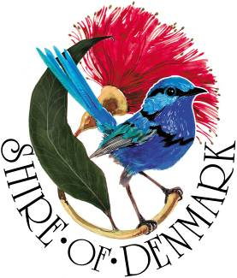
Shire of Denmark
Discover Denmark

Band
Expression of Interest Criteria
Australia Day Event
_________________________________________________________________________________________________

The Shire of Denmark is seeking expressions of interest from bands who would like to perform at our Australia Day community event on Wednesday 26 January 2022.

The Shire of Denmark supports inclusivity and encourages applications from people of diverse backgrounds, cultures and abilities.

Event Information
Event Location: Berridge Park, Hollings Road Denmark
Event Date and Time: 4 - 7 pm, Wednesday 26 January 2022

Requirements
- Each band will be required to play for approximately one 40-minute set.
- P/A and sound manager will be supplied by the Shire
- The music genre must be of broad appeal to suit various age groups and demographics
- The music must be family-friendly with clean lyrics and with no profanity
- Previous experience performing at community events

Selections
Bands will be selected based on the above criteria and on price.

How to apply
Submit your interest online at www.denmark.wa.gov.au/Aus-Day-EOI or email your completed form to enquiries@denmark.wa.gov.au
Expressions of Interest must be submitted by 4pm, Tuesday 4 January 2022.

Expressions of interest should include:
- Cost for the band to perform
- Number of band members
- Music genre
- Previous performing experience at community events
- Requirements and stage plot

Further Information
Please contact the Shire of Denmark Community Development Officer Rosie Arnephie
(08) 9848 0333
Rosemarie.Arnephie@denmark.wa.gov.au
www.denmark.wa.gov.au/Aus-Day-EOI

